P3- Sales Forecasting, Production Planning, Purchase Plan, Procurement



Contents

1 Executive Summary 2

1.1 Objectives 2

1.2 Project Goals 2

2 Phase 1- Sales Forecasting 3

2.1 Sales Forecasting Setup 3

2.1.1 Sync Primary Sales 3

2.1.2 Import Secondary Sales 4

2.1.3 Import Secondary Closing Stock (New) 4

2.1.4 Sales Data Processing 6

2.1.5 Sales Forecasting Process 7

2.1.6 Import Sales Forecasting 8

2.2 Sales Forecasting 9

2.2.1 Sales Projection 9

2.3 Forecasting Details 10

2.4 Forecasting Comparison 11

2.5 Forecasting Summary 12

3 Production Planning 13

3.1 Production Planning 13

3.1.1 Import Factory Production 13

3.1.2 Import Physician Sample Plan 14

3.1.3 Process Production Planning 15

3.1.4 Production Forecasting 16

# Executive Summary

## Objectives

Sales forecasting for an established business is easier than sales forecasting for a new business; the established business already has a sales forecast baseline of past sales.

A business’s sales revenues from the same month in a previous year, combined with knowledge of general economic and industry trends, work well for predicting a business’s sales in a particular future month.

If your business has repeat customers, you can check with them to see if their purchase levels are likely to continue in future. If you don't wish to contact them directly you can infer future activity based on the health of the customer industry.

## Project Goals

Sales Projection is the base of everything for any manufacturing unit. If we do not predict our future, then we will not able to plan for it.

A sales projection is the amount of revenue a company expects to earn at some point in the future. It's a prediction that is synonymous with a sales forecast. Both help determine the health of a company and whether sales will trend upward or downward. Small companies use various input to determine sales projections.

**P3 Planning**

Sales Forecasting

Production Planning

Purchase Plan

**Procurement Planning**

# Phase 1- Sales Forecasting

Sales Projection is the base of everything for any manufacturing unit. If we do not predict our future, then we will not able to plan for it. A sales projection is the amount of revenue a company expects to earn at some point in the future. It's a prediction that is synonymous with a sales forecast. Both help determine the health of a company and whether sales will trend upward or downward. Small companies use various input to determine sales projections.

Sales Forecasting Setup

Sync Primary Sales

|  |  |  |  |  |  |  |  |
| --- | --- | --- | --- | --- | --- | --- | --- |
| Menu | Primary Sales Data | | | Page Name | | data-transfer.html | |
| Purpose | 1. Sync Primary Sales: Fetch Primary Sales Data from [103.253.125.131,5000] .[MendineMaster]. [Transactionbilltaxableamtautomation] (Linked) database and Load into P3 Database. Data fetch Date wise.   SP: usp_01_LoadPrimary_SalesTransactionData | | | | | | |
| Access By | Admin | Outbound Logistics | Inbound Logistics | | Marketing | | Factory |

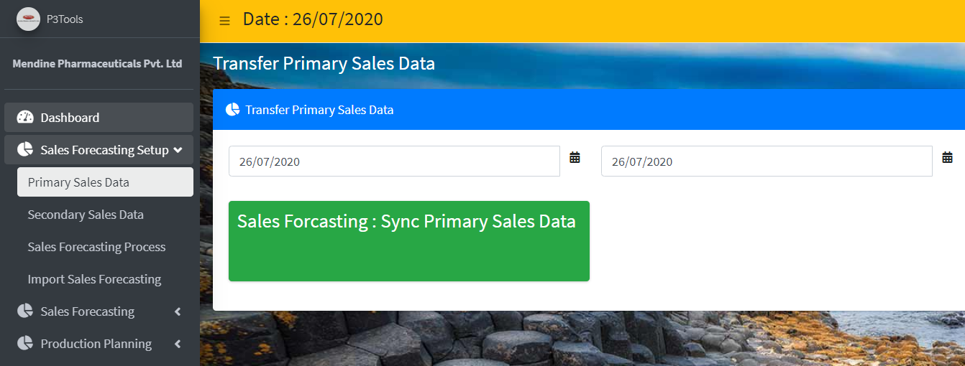

Import Secondary Sales

|  |  |  |  |  |  |  |  |
| --- | --- | --- | --- | --- | --- | --- | --- |
| Menu | Secondary Sales Data | | | Page Name | | secondary_sales.html | |
| Purpose | 1. Download Secondary Sales Data Excel Template from “**Download Secondary Sales Import Template**” 2. Select Secondary Sales Excel file -Browse the source Excel file 3. View Secondary Sales Excel Data - Once Selected the file, click upload Icon to upload and view the uploaded data in the grid. 4. Save Secondary Sales Data – Once view the uploaded data in Grid now you save data to finally import into P3 System.   Here the bellow screen for operation based on role. | | | | | | |
| 1. Table: tbl_P3_SecondarySaleTransDetails_Uploaded | | | | | | |
| Access By | Admin | Outbound Logistics | Inbound Logistics | | Marketing | | Factory |

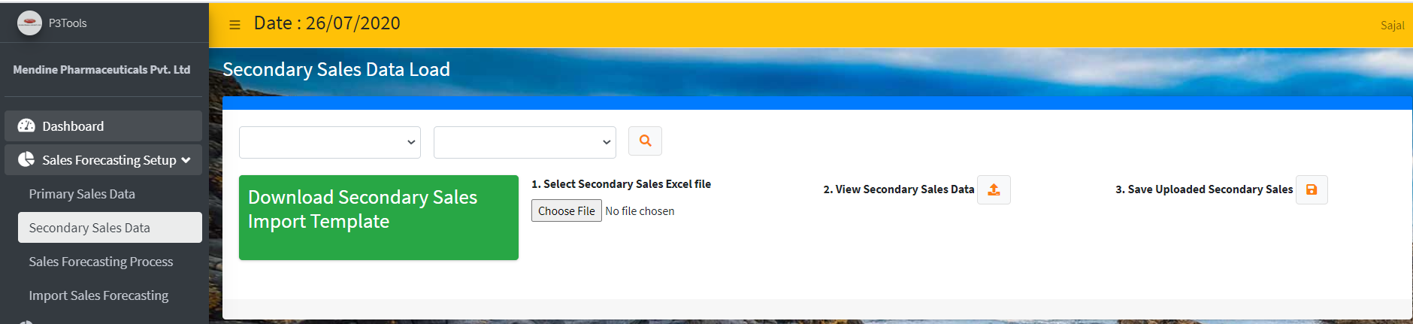

Import Secondary Closing Stock (New)

Import Secondary Closing Stock from Excel Template File month wise. With bellow Template Header

|  |  |  |  |  |  |  |  |  |  |
| --- | --- | --- | --- | --- | --- | --- | --- | --- | --- |
| DivisionName | DepotName | HQ | CustomerCode | CustomerName | ProductCode | ProductName | Pack | UOM | ClosingStockQTY |

|  |  |  |  |  |  |  |  |
| --- | --- | --- | --- | --- | --- | --- | --- |
| Menu | Secondary Sales Data | | | Page Name | | secondary_sales.html | |
| Purpose | 1. Download Secondary Closing Stock Excel Template from “**Secondary ClosingStock- Template.xlsx**” 2. Select Secondary Closing Stock Excel file -Browse the source Excel file 3. View Secondary Closing Stock Excel Data - Once Selected the file, click upload Icon to upload and view the uploaded data in the grid. 4. Save Secondary Closing Stock Data – Once view the uploaded data in Grid now you save data to finally import into P3 System.   Here the bellow screen for operation based on role. | | | | | | |
| Table: tbl_P3_SecondarySaleTransDetails_ClosingStock | | | | | | |
| Access By | Admin | Outbound Logistics | Inbound Logistics | | Marketing | | Factory |

Sales Data Processing

|  |  |  |  |  |  |  |  |
| --- | --- | --- | --- | --- | --- | --- | --- |
| Menu | Sales Forecasting Process | | Page | | data-processing.html | | |
| Purpose | **Process Aggregate Sale Data** | | Aggregate Monthly Primary Sales data. Once Transfer or Sync Sales data, this process needs to invoke. Average value of Primary and Secondary Upload Table | | | | |
| Used SP: usp_02_Process_AggregateSaleData  Output Table: tbl_P3_AGG_SaleTransaction  Input: tbl_P3_PrimarySaleTransDetails_Uploaded  tbl_P3_SecondarySaleTransDetails_Uploaded | | | | |
| **Generate Projection Monthly Data** | | Based on Last Year QTY this current month Projection will be calculated for the Forecasting Type (Logistics/ Marketing)   1. **Logistics** – Primary Sales. Identify Weighted Average Sale [0.6 of last 3months' average + 0.4 of previous year current month] 2. **Marketing** - Secondary Sales.  * HQ wise Secondary Sale Trend * Identify Average Sale * Capture Secondary Closing Stock * Calculate Secondary Projection = (Average Sale *2) Closing Stock | | | | |
| Used SP: usp_03_GenerateProjectionMonthlyData  Table: tbl_P3_SaleProjection_Uploaded  Input Tables: tbl_P3_AGG_SaleTransaction | | | | |
| **Generate Sales Team Projection Data (New)** | | Depot Wise Division Wise Sale Projection will be given by Concerned Sales Team. Depot Wise Division Wise Sale Projection will be given by Concerned Sales Team | | | | |
| Sales Division wise entry provision Primary Sales and Depot wise Closing Stock need to be shown.  Used SP: usp_03_GenerateProjectionMonthlyData_SalesTeam  Table: tbl_P3_SaleProjection_SalesTeam  Input Tables: tbl_P3_AGG_SaleTransaction | | | | |
|  | |  | | | | |
|  | | | | |
| Access By | Admin | Outbound Logistics | |  | |  |  |

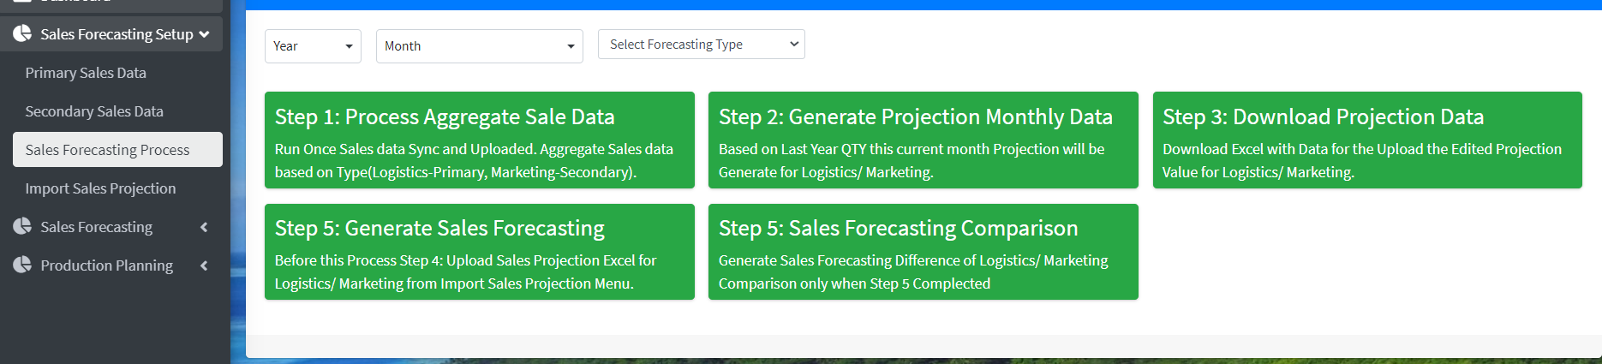

Sales Forecasting Process

|  |  |  |  |  |  |  |  |
| --- | --- | --- | --- | --- | --- | --- | --- |
| Menu | Sales Forecasting Process | | Page | | data-processing.html | | |
| Generate Sales Forecasting | **Generate Sales Forecasting** | | Generate Sales Forecasting Data for the Next Month. Once uploaded Logistics/ Marketing then only generate Forecasting. | | | | |
| Used SP: usp_05_GenerateSalesForecasting  Table: tbl_P3_SaleForecasting | | | | |
| **Sales Forecasting Comparison** | | Edit the Forecasting Data if Market and Logistics projection are varying more than 10% then only user will get a chance to Edit value from Forecasting Comparison Menu. Once all changes are Done then only prepare Sales Forecasting Comparison | | | | |
| Used SP: usp_06_GenerateSalesForecastingComparison  Table: tbl_P3_SaleForecastingComparison | | | | |
| Access By | Admin | Outbound Logistics | | Inbound Logistics | | Marketing | Factory |

Import Sales Forecasting

|  |  |  |  |  |  |  |  |
| --- | --- | --- | --- | --- | --- | --- | --- |
| Menu | Import Sales Forecasting | | | Page | import_salesprojection.html | | |
| Purpose | Once Download Projection (**Download Projection Data)** Excel file for Logistics/ Marketing. Once fill and edited by user Import the Excel into P3 System and followed the bellow Step   1. Select Projection Excel file -Browse the source Excel file 2. View Uploaded Excel Data - Once Selected the file, click upload Icon to upload and view the uploaded data in the grid. 3. Save Uploaded Projection Data – Once view the uploaded data in Grid now you save data to finally import into P3 System.   Here the bellow screen for operation based on role. | | | | | | |
| Table: tbl_P3_PrimarySaleTransDetails_Uploaded  Table: tbl_P3_SecondarySaleTransDetails_Uploaded | | | | | | |
| Access By | Admin | Outbound Logistics | Inbound Logistics | | | Marketing | Factory |

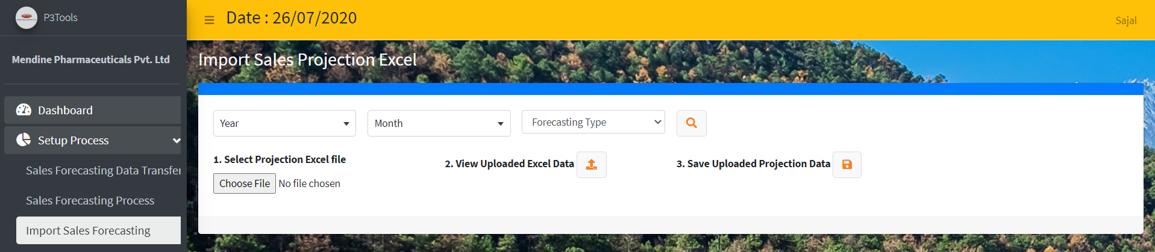

Sales Forecasting

Sales Projection

|  |  |  |  |  |  |  |  |
| --- | --- | --- | --- | --- | --- | --- | --- |
| Menu | Sales Projection | | | Page | sales-projection.html | | |
| Purpose | Sales Projection List by Forecasting Type (Logistics/ Marketing). Data will be filter by Year and month basic.  Table: tbl_P3_SaleProjection_Uploaded | | | | | | |
| Access By | Admin | Outbound Logistics | Inbound Logistics | | | Marketing | Factory |

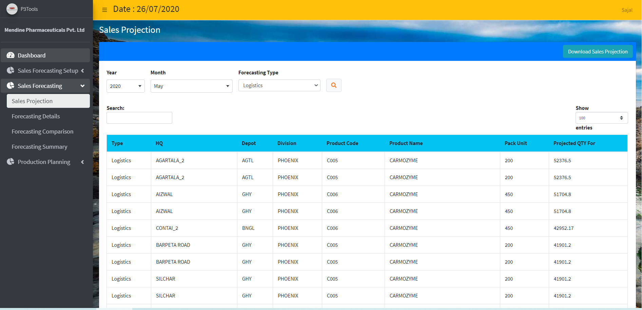

## Forecasting Details

|  |  |  |  |  |  |  |  |
| --- | --- | --- | --- | --- | --- | --- | --- |
| Menu | Forecasting Details | | | Page | sales_forecasting.html | | |
| Purpose | Sales Forecasting List for the month. Report can be filter by following   * Product * Division * Location   Table: **tbl_P3_SaleForecasting** | | | | | | |
| Access By | Admin | Outbound Logistics | Inbound Logistics | | | Marketing | Factory |

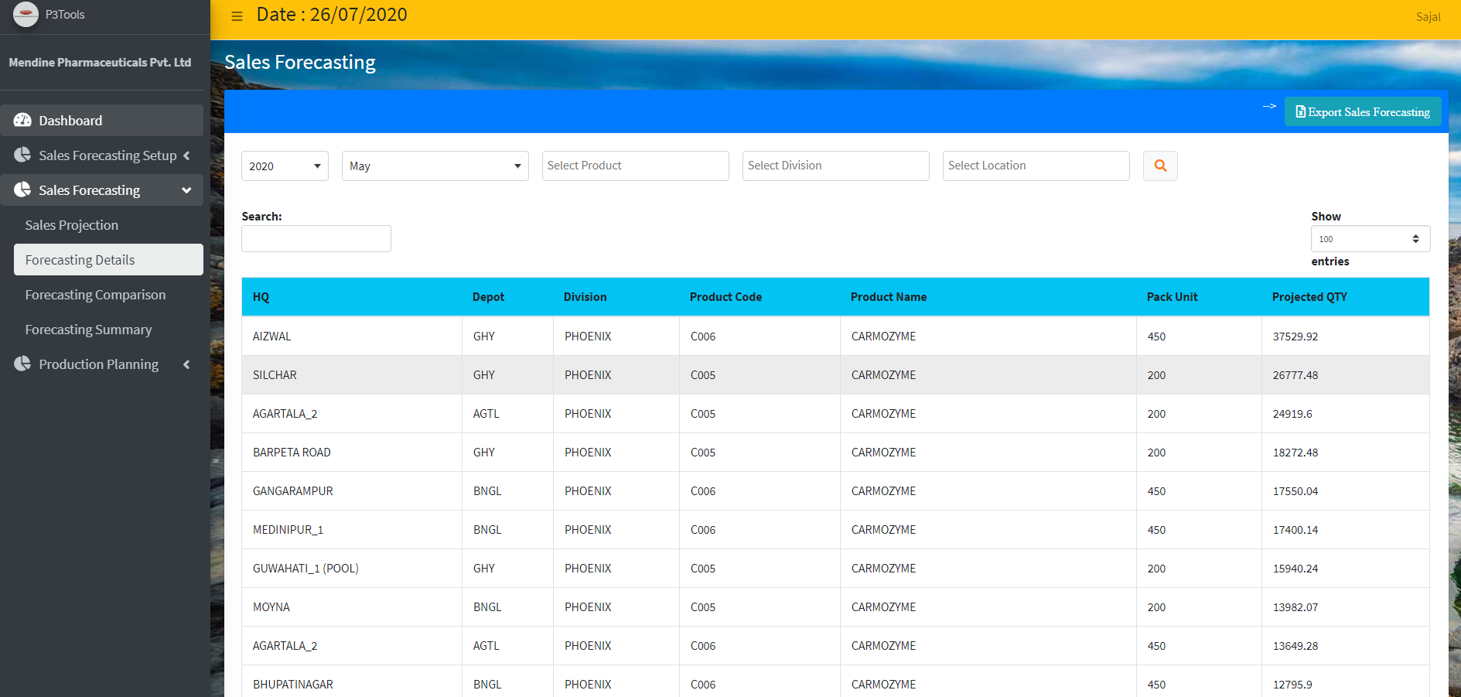

## Forecasting Comparison

|  |  |  |  |  |  |  |  |
| --- | --- | --- | --- | --- | --- | --- | --- |
| Menu | Forecasting Comparison | | | Page | sales_ForecastingComparison.html | | |
| Purpose | Forecasting will manually fill by Marketing & Final Projection will be higher (10%) of both the factor. Then User can able to fill or edit Finial Forecasting value and able to save the Finial Forecasting value. Forecasting Comparison able view month wise value to filter the bellow fields   * Product * Division * Location   Table: tbl_P3_SaleForecastingComparison  SP : | | | | | | |
| Access By | Admin | Outbound Logistics | Inbound Logistics | | | Marketing | Factory |

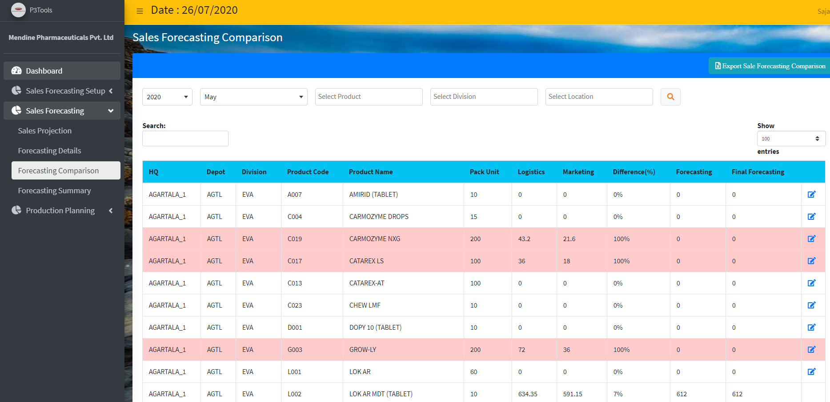

## Forecasting Summary

|  |  |  |  |  |  |  |  |
| --- | --- | --- | --- | --- | --- | --- | --- |
| Menu | Forecasting Summary | | | Page | sales-forecast-summary.html | | |
| Purpose | View Month wise Sales Forecasting Summary report for Next Month Sales by Logistics/ Marketing data.  Table: tbl_P3_SaleForecastingComparison | | | | | | |
| Access By | Admin | Outbound Logistics | Inbound Logistics | | | Marketing | Factory |

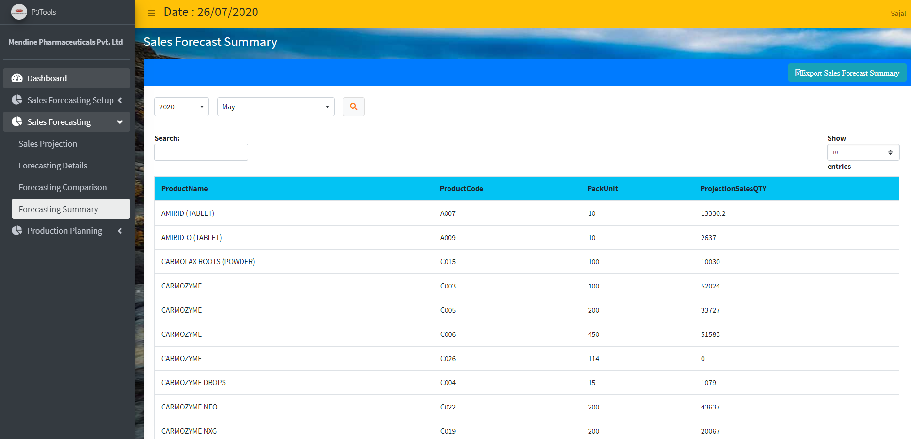

# Production Planning

## Production Planning

Import Factory Production

|  |  |  |  |  |  |  |  |
| --- | --- | --- | --- | --- | --- | --- | --- |
| Menu | Import Factory Production | | | Page | import_factoryproductiontarget.html | | |
| Purpose | Import Factory Production Data sheet from Predefined Excel Template file “Production Plan - Factory Production Target Template.xls” with bellow fields: -   * ProductCode, ProductName, PackUnit, UnitsQTY{Month}-{Year}   Import Process of Excel into P3 System and followed the bellow Step   1. Select File: Production Plan - Factory Production Target Template.xlsx 2. Select Factory Production Excel file -Browse the source Excel file 3. View Uploaded Factory Production Excel Data - Once Selected the file, click upload Icon to upload and view the uploaded data in the grid.   Save Factory Production Data – Once view the uploaded data in Grid now you save data to finally import into P3 System.  To View Data select Year and Month then search the imported data.  Table: **tbl_P3_Production_FactoryProductionTarget_AGG** | | | | | | |
| Access By | Admin | Outbound Logistics | Inbound Logistics | | | Marketing | Factory |

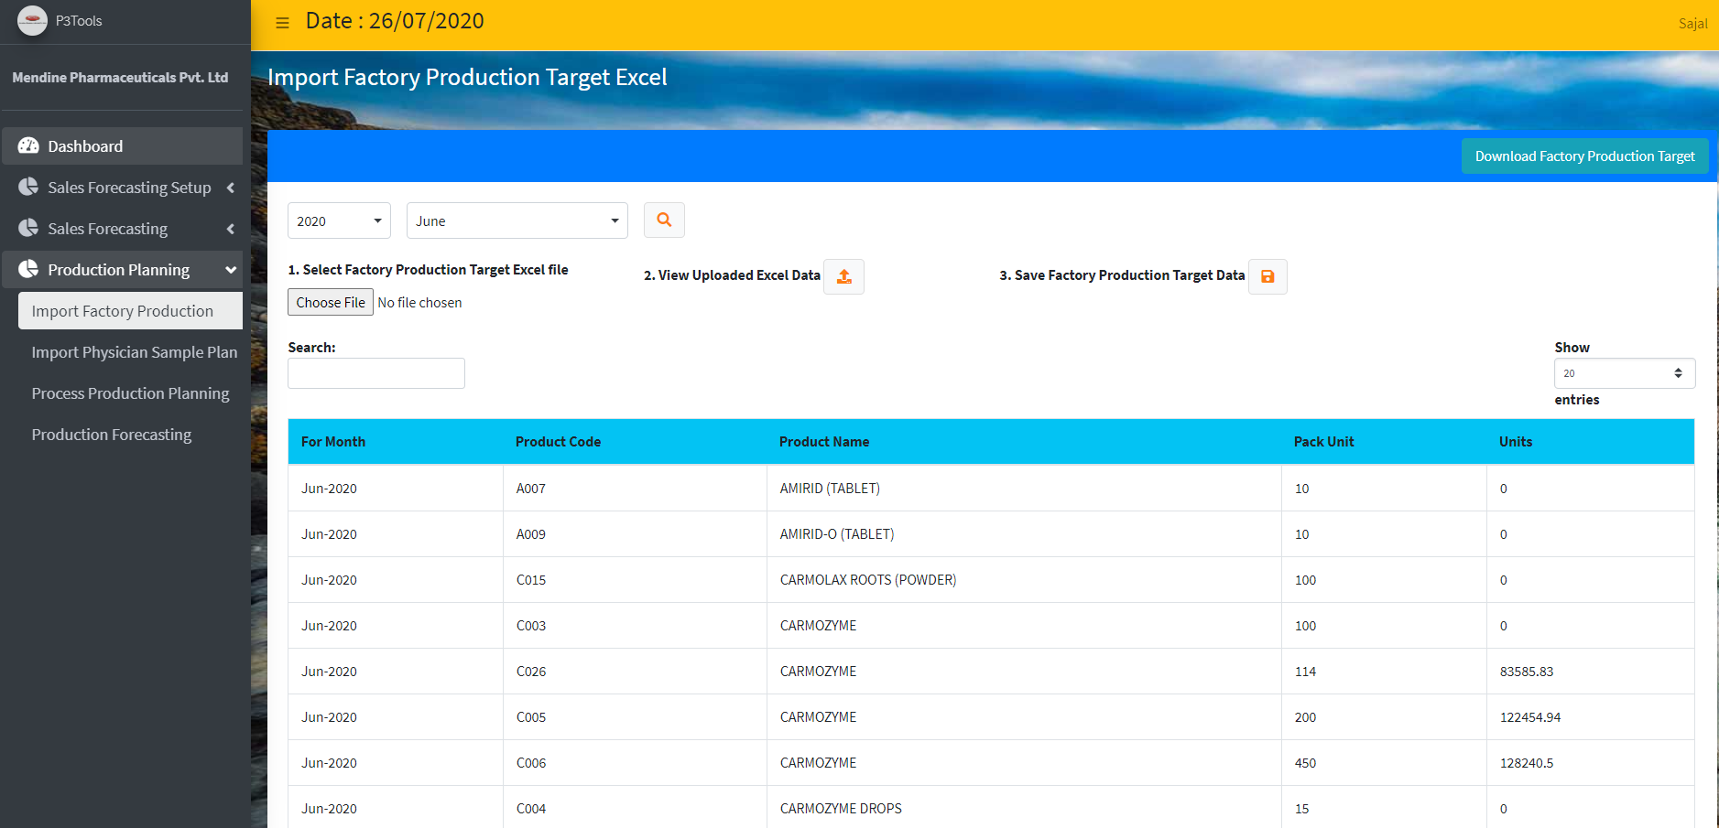

Import Physician Sample Plan

|  |  |  |  |  |  |  |  |
| --- | --- | --- | --- | --- | --- | --- | --- |
| Menu | Import Physician Sample Plan | | | Page | import_PhysicianSamplePlan.html | | |
| Purpose | Import Physician Sample Plan Data sheet from Predefined Excel Template file “Production Plan - Physician Sample Plan Template.xlsx” with bellow fields: -   * ProductName, PackUnit, UnitsQTY{Month}-{Year}   Import Process of Excel into P3 System and followed the bellow Step   1. Select File: Physician Sample - Production Plan - Physician Sample Plan Template.xlsx 2. Select Physician Sample Excel file -Browse the source Excel file 3. View Uploaded Physician Sample Excel Data - Once Selected the file, click upload Icon to upload and view the uploaded data in the grid.   Save Physician Sample Data – Once view the uploaded data in Grid now you save data to finally import into P3 System.  To View Data select Year and Month then search the imported data. | | | | | | |
| Access By | Admin | Outbound Logistics | Inbound Logistics | | | Marketing | Factory |

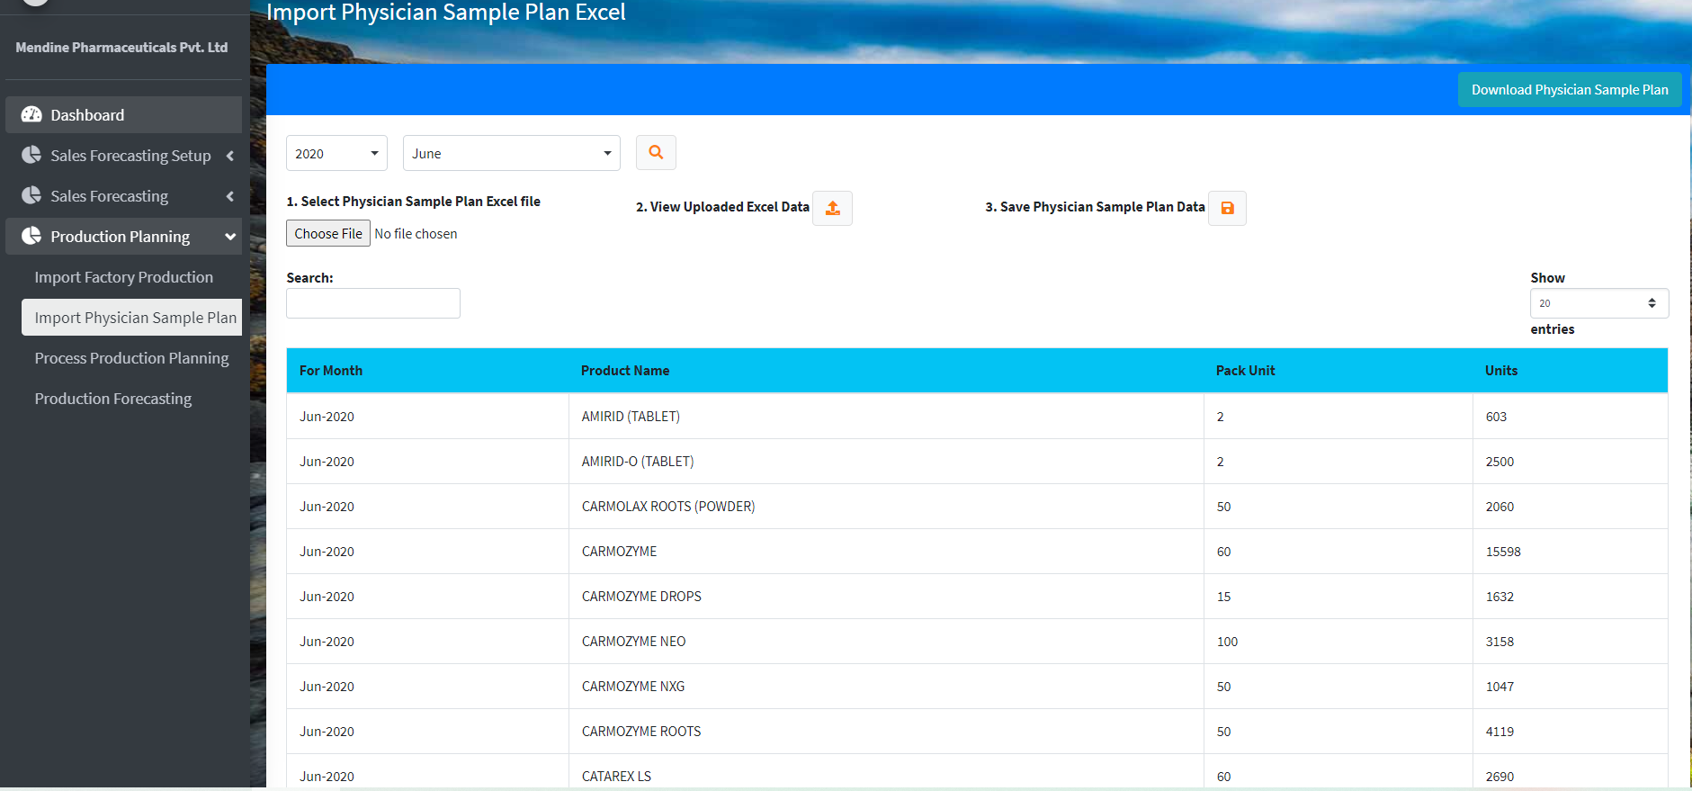

Process Production Planning

|  |  |  |  |  |  |  |  |
| --- | --- | --- | --- | --- | --- | --- | --- |
| Menu | Process Production Planning | | Page | | process_productionplaning.html | | |
|  | This is Control Page of the Product Plan System. | | | | | | |
| Purpose | Sync **Finish Goods**  **SKU Stock Data Trans from SWIL** | | SKU Stock Data Transfer from Easy Report to P3 Database from Closingstock table by executing  EXEC [P3].[dbo].[getclosingstock]  SP: usp_Production_01_TransferDepotStockFromEasyReport  Table: tbl_P3_Production_DepotStock_Raw  Last 2 month Data (Current: March, Fetch 31st Jan Data) | | | | |
| Sync SQL WIP Stock | | EasyReports3.6].dbo.TD_Mst_StockItem Data Transfer from Tally DB to P3 Database for Company=2, StockGroup like 'ready to fill' and GodownName like 'Un Approved Store'  SP: usp_Production_03_TransferWIPStockFromEasyReport  Table: tbl_P3_Production_WIPStock_Raw  Please Confirm the Date (Start Date and End Date) | | | | |
| Process Aggregate Depot Stock | | Aggregate Depot Stock Raw data for the Month.  SP: usp_Production_02_Process_AggregateDepotStock  Table: tbl_P3_Production_DepotStock_AGG | | | | |
| Process Aggregate WIP Stock | | Aggregate Factory WIP Stock for the month for further calculation.  SP: usp_Production_04_Process_AggregateWIPStock  Table: tbl_P3_Production_WIPStock_AGG | | | | |
| Finial Step: Generate Production Planning | | Calculate Finial Production Plan for the Month. On calculation the finial QTY for Product wise and SKU wise.  SP: usp_Production_05_ProcessProductionPlanning  Table: tbl_P3_Production_Forecasting_Product  tbl_P3_Production_Forecasting_SKU | | | | |
| Access By | Admin | Outbound Logistics | | Inbound Logistics | | Marketing | Factory |

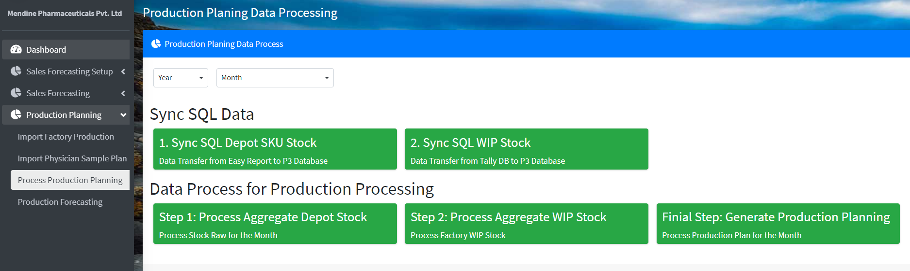

Production Forecasting

|  |  |  |  |  |  |  |  |
| --- | --- | --- | --- | --- | --- | --- | --- |
| Menu | Production Forecasting | | | Page | Productionforecasting.html | | |
| Purpose | In Production Forecasting shows 3 Tab for shows data product and SKU data   * Volume Conversion, Volume Charge, Final Charge Unit   You Can able to download in a single Excel file.  Table: tbl_P3_Production_Forecasting_Product  Table: tbl_P3_Production_Forecasting_SKU | | | | | | |
| Access By | Admin | Outbound Logistics | Inbound Logistics | | | Marketing | Factory |

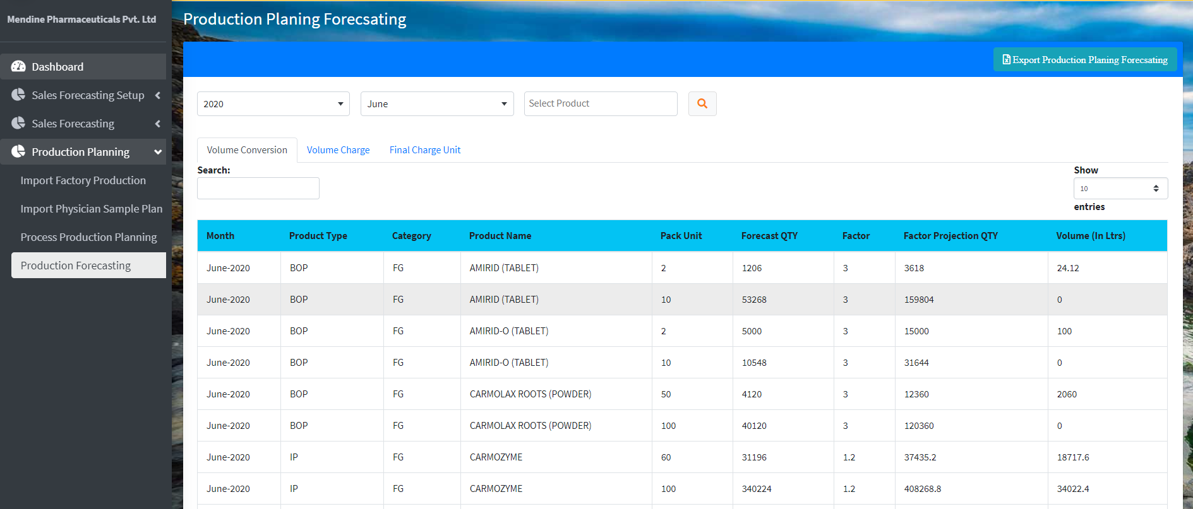

Tables:

* tbl_P3_SaleForecastingComparison
* ~~tbl_P3_SaleForecasting~~
* tbl_P3_SaleProjection_Uploaded
* tbl_P3_SaleProjection_SalesTeam
* tbl_P3_AGG_SaleTransaction
* tbl_P3_SecondarySaleTransDetails_Uploaded
* tbl_P3_PrimarySaleTransDetails_Uploaded